TITLE OF THE ARTICLE
First Author, Second Author, Third Author, …, Sixth Author
University, Faculty (optional), Department (optional)
* Corresponding author e-mail address: email@correspondingauthor.com

PAPER ID: SITXXX

Abstract
The abstract summarizes the content of the article. It must have up to 300 words. At the end of the abstract, it is also mandatory to specify at least 3 and at most 5 keywords related to the subject of the article. Use just one paragraph for the abstract. In this template you can find all the formatting requirements. Use Times New Roman font in size 12 throughout the document, unless for tables, figures and equations. The abstract must be written in English. The remainder of the paper can be written either in Portuguese or English. The abstract summarizes the content of the article.

Keywords: Keyword 1, Keyword 2, Keyword 3, Keyword 4, Keyword 5.

acknowlegdements
If applicable, insert here the acknowledgements. In the next pages any information that could potentially uncover the authors identity may be provided. Before uploading the PDF file of the article, please remove all the properties (metadata) of the file as names, etc.

INTRODUCTION
The introduction must start in the beginning of page 2. In the introduction, the authors must present the subject and the main objectives of the study in a summarized way, covering aspects such as the objectives, the justification and/or the motivation of the study and the definition of the problem. The complete article is expected to have 10 pages at maximum.

BODY OF THE ARTICLE
This is the main body of the article. Use 1 to 4 sections (e.g., bibliographic review, methodology, results, conclusions) This chapter is an example of the various chapters that the authors can use to report their respective studies, including the study methodology, the analysis and the final results.
From this point onwards, this sample article exposes examples of how tables, figures and bibliographic sources should be referenced in-text.
All figures and graphics inserted in the document must be JPEG, SVG, GIF, PNG or VSD (Microsoft Visio Documents) with at least 300 dpi resolution. They must be Arabically-numbered, centralized in the column and followed by the corresponding captions, as done with Figure 1, which is the logotype of the Brazilian Air Transportation Research Society (SBTA). All references to figures must be done using cross-references, natively available on all recent versions of Microsoft Word and other processors, and should only contain the label ‘Figure’ and its number in the document.
Figure 1 Brazilian Air Transportation Research Society Logo. Source: SBTA.

Tables must also be Arabically-numbered, centralized in the column and followed by the corresponding captions. In light of Table 1, which lists all volumes and issues of JBATS published until 2010, it is important to emphasize that, just like figures, all tables must be in-text referenced using cross-references and should only contain the label ‘Table’ and its number in the document. Note that the table outer borders are invisible. All the inserted material must be either a table or a figure. Avoid inserting tables as images.
Table 1 Issues and Volumes of JBATS published until 2010
Volume | ISSUE | Date | ISSN
1 | 1 | 2005 | 1808-3331
2 | 1 | 2006 | 1808-3331
2 | 2 | 2006 | 1808-3331
3 | 1 | 2007 | 1808-3331
3 | 2 | 2007 | 1808-3331
4 | 1 | 2008 | 1808-3331
4 | 2 | 2008 | 1808-3331
5 | 1 | 2009 | 1808-3331
6 | 1 | 2010 | 1808-3331
6 | 2 | 2010 | 1808-3331

When inserting equations on the text, they must be written according to the default settings of mathematical editors available in Office Suites, such as Microsoft Math Type and Microsoft Equation Editor. They must be Arabically-numbered in parentheses and this number should be used in all in-text references. As an example, (1) shows the general equation of Newton’s Second Law of Motion.
(1)
In cases in which figures, tables and equations are bigger in size than the text columns, they can be inserted in all width of the page. The examples depicted on Figure 2, Table 2 and Equation (2) illustrate how those elements must be presented in-text. Note that in Figure 2 there is no indication of source, once it is from the author itself.

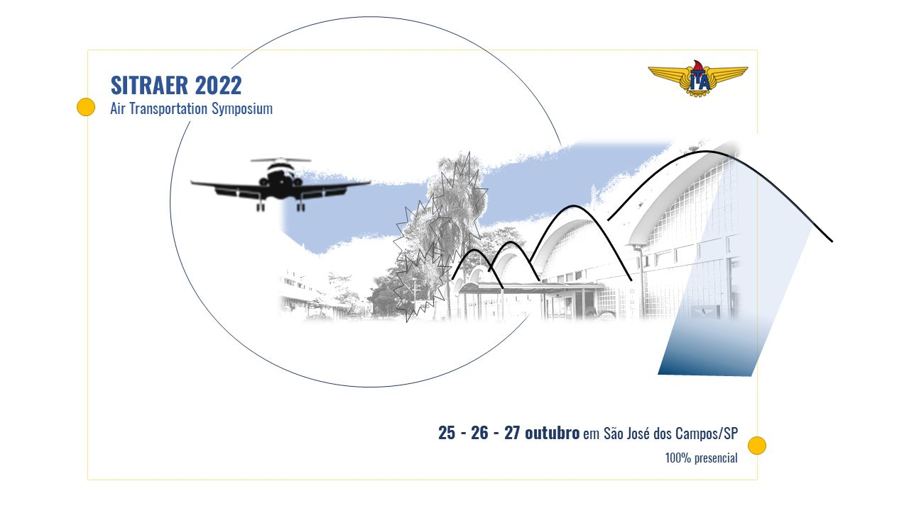
Figure 2 SITRAER's 2022 edition official image.

Table 2 Brazilian IPCA Inflation Index
 | JAN | FEB | MAR | APR | MAY | JUN | JUL | AUG | SEP | OCT | NOV | DEC | YEAR
2010 | 0,75 | 0,78 | 0,52 | 0,57 | 0,43 | 0,00 | 0,01 | 0,04 | 0,45 | 0,75 | 0,83 | 0,63 | 5,91
2011 | 0,83 | 0,80 | 0,79 | 0,77 | 0,47 | 0,15 | 0,16 | 0,37 | 0,53 | 0,43 | 0,52 | 0,50 | 6,50
2012 | 0,56 | 0,45 | 0,21 | 0,64 | 0,36 | 0,08 | 0,43 | 0,41 | 0,57 | 0,59 | 0,60 | 0,79 | 5,84
2013 | 0,86 | 0,60 | 0,47 | 0,55 | 0,37 | 0,26 | 0,03 | 0,24 | 0,35 | 0,57 | 0,54 | 0,92 | 5,91
2014 | 0,55 | 0,69 | 0,92 | 0,67 | 0,46 | 0,40 | 0,01 | 0,25 | 0,57 | 0,42 | 0,51 | 0,78 | 6,41
2015 | 1,24 | 1,22 | 1,32 | 0,71 | 0,74 | 0,79 | 0,62 | 0,22 | 0,54 | 0,82 | 1,01 | 0,96 | 10,67
2016 | 1,27 | 0,90 | 0,43 | 0,61 | 0,78 | 0,35 | 0,52 | 0,44 | 0,08 | 0,26 | 0,18 | 0,30 | 6,29
2017 | 0,38 | 0,33 | 0,25 | 0,14 | 0,31 | -0,23 | 0,24 | 0,19 | 0,16 | 0,42 | 0,28 | 0,44 | 2,95
2018 | 0,29 | 0,32 | 0,09 | 0,22 | 0,40 | 1,26 | 0,33 | -0,09 | 0,48 | 0,45 | -0,21 | 0,15 | 3,75
2019 | 0,32 | 0,43 | 0,75 | 0,57 | 0,13 | 0,01 | 0,19 | 0,11 | -0,04 | 0,10 | 0,51 | 1,15 | 4,31
2020 | 0,21 | 0,25 | 0,07 | -0,31 | -0,38 | 0,26 | 0,36 | 0,24 | 0,64 | 0,86 | 0,89 | 1,35 | 4,52
2021 | 0,25 | 0,86 | 0,93 | 0,31 | 0,83 | 0,53 | 0,96 | 0,87 | 1,16 | 1,25 | 0,95 | 0,73 | 10,06

(2)

When including citations, authors must use the author-date system and should also include the relevant page numbers if applicable.

CITATIONS
All references mandatorily cited in the article must be referenced. All references must be alphabetically-listed and should include the authors’ names, initials, year of publication in parentheses and both the source of publication and its publisher. As for articles extracted from journals, pieces of information such as the journal title, the volume number, either month or issue number and the page numbers of the article are also necessary. The following examples present references extracted from papers, journals and web sites. You can use automatic formatting of references. Such tool is natively available in some processors, including Word.
For instance, according to Ben-Akiva & Lerman (1985) and Ortúzar & Willumsen (2011), we have a citation.
Alternatively, authors can be cited at the end of the paragraph. (Ortúzar & Willumsen, 2011).
Use up-to-date references, preferably peer-reviewed journal articles (Farzadnia & Vanani, 2022). Conference articles (Robinson, 2017) and technical standards (ABNT, 2020) can be used if necessary, as well as websites (ANAC, 2021) , thesis (Abdal, 2015), books (Ortúzar & Willumsen, 2011) and other sources.
Use APA standards to format the references, as displayed in the references section.

References
Abdal, A. (2015). Sobre regiões e desenvolvimento: os processos de desenvolvimento regional brasileiro no período 1999-2010. São Paulo: Tese de Doutorado, Faculdade de Filosofia, Letras e Ciências Humanas, Universidade de São Paulo.
ABNT. (2020). NBR 9050:2015 Acessibilidade a edifcações, mobiliário, espaços e equipamentos urbanos. Rio de Janeiro: Associação Brasileira de Normas Técnicas.
ANAC. (2021, Jul 14). Agência Nacional de Aviação Civil. Lista de aeródromos civis cadastrados. Retrieved Jun 14, 2022, from https://www.gov.br/anac/pt-br/assuntos/regulados/aerodromos/lista-de-aerodromos-civis-cadastrados
Ben-Akiva, M. E., & Lerman, S. R. (1985). Discrete choice analysis: theory and application to travel demand, (Vols. 9,). Cambridge: MIT Press,.
Farzadnia, S., & Vanani, I. R. (2022). Identification of opinion trends using sentiment analysis of airlines passengers' reviews. Journal of Air Transport Management, 103, 102232. doi:https://doi.org/10.1016/j.jairtraman.2022.102232
Ortúzar, J. D., & Willumsen, L. G. (2011). Modelling transport, (4 ed.). New, Jersey, USA: John Wiley & Sons.
Robinson, S. (2017). A Tutorial on Simulation Conceptual Modeling. Proceedings of the 2017 Winter Simulation Conference (pp. 565-579). Las Vegas: Institute of Electrical and Electronics Engineers.

.

